BRIDGING HUMAN INTUITION AND MACHINE INTELLIGENCE IN ECONOMIC STRATEGY

Ishita Gopi, Architha R, Avani M Sunil, Priyadarshini V, Jyoti Yadav, Panchami Mallik, G,Trinethra.

Assistant professor, MBA Student 2025-27 batch

JAIN (DEEMED to be University),
CMS Business School,
Bangalore, India

I ABSTRACT
The integration of Artificial Intelligence and human insight marks a new era of economic intelligence. AI delivers precision, real-time analysis, and predictive power, while human intuition and ethics provide balance and judgment. Together, they form a hybrid intelligence that enhances decision-making, drives innovation, and ensures responsible, transparent, and human-centered economic progress.

II. INTRODUCTION
In the contemporary dynamic global economy, Artificial Intelligence (AI) is now an agent of change that reorganizes how people, businesses, and governments make strategic and economic choices. The deployment of AI in economic systems has added a new level of intelligence that integrates human thinking and intuition with the mechanical precision and analytical capabilities of machines. As economies become more sophisticated and data-centric, the power to make smart, timely, and strategic decisions is not just a function of experience anymore. It needs to be synthesized with human intelligence and the predictive and adaptive functions of AI. This convergence, also called economic intelligence, has become an essential framework for creating smarter, evidence-driven strategies that improve efficiency, innovation, and sustainability.
Economic intelligence has long entailed collecting, analyzing, and interpreting economic information to inform decision-making. With the introduction of AI, the process has been transformed. Machine learning models, neural networks, and big data analytics can now help decision-makers sort through gigantic amounts of structured and unstructured data in real time. Such technologies detect trends, predict market tendencies, and suggest best options that may not be apparent to human eyes. For instance, in financial markets, systems powered by AI make price predictions and handle risk portfolios; in public policy, they help governments in resource allocation and anti-inflation strategies. However, whereas AI offers the quantitative underpinning of choices, human instinct—developed from experience, ethical thought, and situational awareness—is important to interpret the insights and validate that decisions mesh with social and moral principles.
The incorporation of AI into strategic economic thought is not simply a technological innovation but also a paradigmatic change in philosophy of decision-making. The human intuition, once and still prized as the hallmark of leadership and innovation, now engages with machine wisdom to produce a hybrid approach to strategic thinking. This one stresses harmonization over competition among human and artificial reasoning. Whereas machines are better suited to examine data and determine logical consequences, humans bring emotional intelligence, imagination, and ethical judgment—attributes that are difficult to replicate through machines. Together, they create a symbiotic partnership in which AI enriches human capability, allowing human beings and organizations to make wiser, quicker, and more integrated economic decisions.
Also, the application of AI in economic intelligence boosts strategic foresight—the capability to foresee upcoming events and act ahead. By using predictive analytics and scenario modeling, AI systems offer insights into future market trends, consumer behavior patterns, and geopolitics changes. Such insights enable businesses and policymakers to anticipate future challenges and exploit new opportunities. Yet the challenge is how to ensure that AI-driven decisions are transparent, unbiased, and human-centric. The excessive use of algorithmic decision-making sometimes results in ethical issues, data privacy, and socio-economic disparities. Therefore, finding a balance between human judgment and AI autonomy is critical in order to ensure the integrity and inclusivity of economic strategy.
Oregon nationally, AI has reshaped strategic planning and management practices. Businesses today depend on AI tools to maximize operations, predict demand, and create pricing strategies based on consumer information. AI-enabled economic intelligence systems have the ability to assess market sentiment, performance of competitors, and global supply chain trends in real time. These capabilities eliminate uncertainty and make strategic decisions more precise. For example, multinational companies utilize AI to forecast economic downturns and balance investment portfolios accordingly. Likewise, startups use AI-driven analytics to spot niche markets and innovate quickly. These examples demonstrate how AI fosters agility, precision, and competitiveness across economic sectors.
Yet, despite the impressive capabilities of AI, human involvement remains indispensable. Intuition, empathy, and cultural understanding enable humans to interpret data in ways machines cannot. Economic strategy often involves subjective elements—such as understanding consumer emotions, ethical implications, and long-term social impacts—that cannot be quantified solely through data analysis. So, the future of strategic economic thinking lies in closing the gap between human insight and algorithmic intelligence. Where combined well, AI maximizes human potential, translating intuition into quantifiable results and enabling economic decisions that are more adaptable and robust.
In summary, Artificial Intelligence is not a substitute for human decision but an articulate amplification of it. The blending of human insight and machine intelligence forms an equilibrium in which more intelligent, ethical, and visionary economic approaches are created. With the future advancement of AI, the test for economists, strategists, and policymakers will be to foster this symbiosis in a responsible way—such that technology complements human wisdom and does not diminish it. This research paper seeks to explore how AI-driven economic intelligence influences strategic thinking, the ways in which humans and machines collaborate in decision-making, and the future implications of this relationship for global economic systems. By understanding and embracing this collaboration, societies can harness AI not just as a technological tool, but as a partner in achieving intelligent, sustainable, and human-centered economic progress.

III.REVIEW OF LITERATURE

(Risso et al., 2022)¹ Human–machine interaction research stresses that while AI supports data-based decision-making, actual competitive advantage comes from enhancing human creativity, ethics, and emotional intelligence with technological effectiveness.

(Padhy, 2025)² Maximum organizational effectiveness in the digital era is the argument of the research that exists in combining human gut, creativity and moral judgment with machine efficiency and algorithmic accuracy.

(Tasleem et al., 2024b) ³The article explains how the unification of Artificial Intelligence and Edge Computing transforms data processing by making faster, localized, and intelligent decisions. It seeks out benefits like reduced latency, enhanced efficiency, and more intelligent real-time applications, and explores challenges and possible avenues of AI-edge convergence research.

(Eicher & Mea, 2024) ⁴The paper discusses the concept of Cognitive Arbitrage with a view to optimal organizational performance through human brainpower-AI automation balancing. The paper brings AEDG and HRAIC models forward to assist in making decisions and building capabilities. The study aims to support leaders in introducing AI strategically into action while maintaining human imagination and control within intelligent systems.

(Liang, 2004) ⁵It is in place to offer a theoretical model accounting for how human organizations can build adaptive, evolving intelligence by mediating inner self-enhancement and external demands, and how co-evolving agents are present in complicated systems.

(Mamphiswana & Sinha, 2019) ⁶A phased method as the strategic template towards economic system preparedness for sustainability" —presents a conceptual model for the way new economies can integrate intelligent systems and human labour in the workplace.

(Trunk et al., 2020)⁷ It discusses how AI can support decision-making in uncertain contexts within organizations. It provides a conceptual framework of how humans can use AI, discuss challenges and needs for effective integration, and demands ethical guidelines and training to steer the evolving human–AI collaboration.

(Casares, 2018)⁸The profound economic and social reforms caused by the rise of intelligent machines, a transformation from traditional Turing Machines to advanced Inference Machines. This transformation ought to create more productivity, changes in societal structures, and challenges such as technological unemployment and widening of income gaps. The writer emphasizes the need to implement new governance paradigms to deal with these complexities and turn democracies systemic in a world that is becoming increasingly machined.

(Ansari et al., 2020)⁹It presents a detailed examination of the manner in which human and machine can work together in cyber–physical systems. It offers several models and frameworks of collaboration with recognition of the issues and benefits of integrating human intelligence with machine capabilities in complicated systems.

(Raikov & Pirani, 2022)¹⁰It explores human consciousness combined with machine intelligence through hybrid AI paradigms. It promotes a two-way strategy: top-down from human cognition and bottom-up from machine learning to create sustainable and useful human–machine interactions. The research applies methods like cognitive modelling, category theory, and quantum field theory to address ethical and societal challenges in AI design.
(Mene et al., 2025)¹¹integration of game theory and artificial intelligence strengthens decision-making by combining strategic interaction models with computational intelligence. This synergy enables the analysis of complex, multi-agent environments, fostering optimal strategies and predictive insights. Its applications extend across economics, finance, cybersecurity, and beyond, offering smarter, data-driven solutions to real-world strategic challenges.
(Ghadage, 2025)¹² It is not directly relevant to economic strategy research, as it primarily discusses the synergy between human and artificial intelligence to enhance cognitive abilities. The focus is on how AI can augment human thinking, decision-making, and problem-solving capacity rather than on its implications for economic strategy or market-level research
(Harré, 20211 ¹³The paper reviews the convergence of AI, psychology, and economics using an information theory framework. It highlights both progress and challenges in aligning human intuition with machine intelligence for decision-making. The discussion extends to potential applications in socioeconomic systems and the development of autonomous economic environments capable of operating with minimal human intervention.
(Pescetelli, 2021)¹⁴Hybrid intelligence integrates human and machine intelligence to solve complex problems more effectively. A proposed taxonomy categorizes their interaction into assistants, peers, facilitators, and system-level operators. The approach emphasizes building collaborative, adaptive, responsible, and explainable systems that combine human intuition with computational precision for improved decision-making and task performance.
(Kitsios & Kamariotou, 2021)¹⁵The paper synthesizes existing research on AI and corporate strategy, outlining gaps in how AI is strategically utilized while emphasizing the need for further inquiry. Its focus is primarily on theoretical contributions instead of empirical evidence, offering conceptual clarity on the role of AI in shaping strategic direction rather than presenting measurable outcomes from real-world implementations.
(Shrestha et al., 2019)¹⁶The paper presents a framework for integrating human and AI-based decision-making to enhance organizational decision quality. It identifies key contingency factors that influence when and how hybrid decisions should be adopted, and classifies integration into three structural categories, outlining how firms can effectively combine human judgment with AI capabilities for better strategic outcomes.
(Raisch & Fomina,2024)¹⁷Human–AI collaboration in problem-solving depends on the specific processes used to integrate human and machine intelligence. The paper identifies three hybrid processes—autonomous, sequential, and interactive—each shaping decision dynamics differently. This framework contributes to behavioral theory by incorporating a technology-conscious perspective on how human and AI agents jointly influence outcomes.
(Kunz et al., 2025)¹⁸The paper develops an integrative framework for human–machine collaboration in service industries, emphasizing teamwork over replacement or automation. It highlights how humans and AI can complement each other to enhance service delivery, offering a comprehensive foundation for future research and practical applications. The framework supports both theoretical exploration and implementation in real-world organizational context

(Parkes & Wellman, 2015)¹⁹The development of AI agents capable of reasoning and acting in economic contexts is advancing, with the concept of a “machina economicus” emerging. Economic theories, especially mechanism design, are considered more applicable to AI than human agents. This progress highlights the need for a new scientific framework to understand, model, and design AI-driven economic systems.
(Qin et al., 2023)²⁰AI is significantly influencing economic development, as shown by a bibliometric analysis and literature review of 2,211 documents. Research highlights its role in intelligent decision-making, social governance, labor and capital management, Industry 4.0, and innovation. The study demonstrates rapid growth in publications, reflecting increasing academic and practical interest in AI’s economic and societal impact.
Jarrahi, M. H. (2018)²¹AI is increasingly involved in organizational decisions, raising fears of replacing humans. However, this article emphasizes collaboration—AI enhances analytical tasks and handles complex data, while humans contribute intuition and judgment in uncertain situations. Together, they create a balanced decision-making process that augments human intelligence rather than replacing it
Huang, M., & Rust, R. T. (2018)²²AI is transforming services by taking over many tasks—driving innovation but also threatening jobs. The theory of AI job replacement explains that machines progress from mechanical to analytical, then intuitive and empathetic tasks. As AI advances, humans must focus more on soft skills, though eventually, even these may be automated.
Dwivedi, Y. K., Hughes, L.²³Since the Industrial Revolution, technology has transformed human work by overcoming physical limits. Similarly, AI now drives a new wave of change—augmenting and sometimes replacing human roles across industries like finance, healthcare, and manufacturing. This study explores AI’s vast potential, challenges, and societal impacts shaping the future of innovation.
Koohang, A., Nord, J. H., Ooi, K., Tan, G. W., Al-Emran, M.²⁴The metaverse, seen as the next stage of the Internet, combines virtual, augmented, and mixed reality to create immersive real-time experiences. This paper explores how the metaverse could transform industries like marketing, education, healthcare, and banking by offering new opportunities, posing challenges, and suggesting directions for future research.
(Elhassan & Klett, 2015)²⁵ Evidence suggests that accelerated urbanization and population transitions have heightened the need for an educated and trained workforce. Academics highlight the necessity of articulation between higher education and changing labor market needs. Incorporation of technology in the education system and employment apparatus is regarded as necessary to improve living and working conditions. Therefore, articulation plays a major role in achieving the maximum socio-economic dividend of development.
(Elhassan & Klett, 2015) ²⁶Evidence suggests that accelerated urbanization and population transitions have heightened the need for an educated and trained workforce. Academics highlight the necessity of articulation between higher education and changing labor market needs. Incorporation of technology in the education system and employment apparatus is regarded as necessary to improve living and working conditions. Therefore, articulation plays a major role in achieving the maximum socio-economic dividend of development.
(Abir et al., 2024) ²⁷Research indicates that Artificial Intelligence (AI) and Machine Learning (ML) are critical in narrowing economic growth gaps between BRICS countries. Authors point to the application of data-driven approaches like predictive modeling, clustering, and natural language processing to inform decision-making. Focus is put on coupling ethical frameworks to guarantee responsible technology use. This convergence supports sustainable development and optimizes the extent of economic consequences.
(Dellermann et al., 2019) ²⁸Academics highlight that Academic Intelligence combines human thinking with machine intelligence to generate better decision-making results. This synergy takes advantage of human and machine complementarities, improving analytical accuracy and creativity. Studies indicate that this synergy can facilitate super-human-level performance in dealing with complex and dynamic economic problems. Hybrid Intelligence, therefore, has great potential for promoting strategic economic planning and innovation.
(Dodeja et al., 2023)²⁹Research evidence shows that personality, especially conscientiousness, had a strong impact on user preference for strategy recommendation systems. There is supporting evidence from a controlled human-subjects experiment with 60 participants that confirms the relationship. The investigation used a systematic approach in comparing the responses of users to different recommendation modalities. The findings indicate that differences in personality among individuals are key in determining system usability and acceptance.
(Okoh et al., 2023)³⁰ Artificial Intelligence (AI) technologies play a very crucial role in increasing the contribution of human capital development towards economic progress. Cross-country analyses and empirical evidence confirm that embracing AI enhances productivity, innovation, and efficiency of the workforce. Qualitative analyses also confirm how AI-powered education and skill development initiatives promote flexible learning and talent maximization. Case studies from various economies further confirm the complementary nature between AI adoption and human capital development in the facilitation of sustainable economic growth.

IV RESEARCH METHODOLOGY
RESEARCH DESIGN:
The research employs a descriptive and exploratory research design to examine the manner in which human instinct and machine intelligence collectively inform economic strategy. It aims to determine the contribution of economic intelligence to strategic decision-making, delve into the connection between purposeful strategy and enduring competitive advantage, and establish appropriate tools and frameworks for combining human and artificial intelligence in strategy formulation. The study utilizes a mixed-methods design, which integrates both quantitative and qualitative methods. The primary data were gathered using a sequenced Google Form with multiple-choice, Likert-scale, and open-ended questions, administered to MBA students, professionals, and analysts via convenience sampling. The quantitative information assisted in the identification of quantifiable trends and perceptions about the use of AI to make decisions, while qualitative information gave more insight into human intuition, ethical aspects, and creative thinking in economics. The information was processed with descriptive statistics and interpretive reasoning to make significant conclusions about how human and machine intelligence integration goes towards successful and sustainable economic approaches.
RESEARCH GAP:
The research utilizes a descriptive and exploratory type of study design. The primary objective is to examine the interplay between AI and human intuition in the process of economic decision-making at the strategic level. The research is aimed at unveiling the different attitudes, habits of use, and the respective contributions of human and machine intelligence in the economic strategy-making process.
The study uses a structured Google Form questionnaire named “Bridging Human Intuition and Machine Intelligence in Economic Strategy” for its primary data. The questionnaire included various types of questions like multiple-choice, Likert scale, and open-ended to provide insights that are both quantitative and qualitative. The sample of respondents consisted of MBA students, professionals, and analysts who were chosen based on convenience sampling.

The area of concentration for the data that was collected included the following:
• Usage of AI tools
• Trust in insights provided by machines
• The role of human intuition as perceived by the people interviewed in making strategic decisions
The research adhered to ethical principles such as ensuring confidentiality and obtaining informed consent from participants. The data analysis aimed to reveal the patterns, the different viewpoints and the points of co-operation between human thinking and AI analytics.

OBJECTIVES
1. To understand the role of economic intelligence in strategic decision-making
2. To explore the link between purpose-driven strategy and long-term competitive advantage
3. To identify tools and frameworks for integrating economic intelligence into strategy

DATA COLLECTION:
Primary data was collected through a structured Google Form titled "Bridging Human Intuition and Machine Intelligence in Economic Strategy”. The questionnaire used multiple-choice, Likert scale, and open-ended questions. The primary themes included demographic data, familiarity with AI tools, trust in machine-based insights, and the role of human intuition in economic decision-making. Respondents were MBA students, professionals, and analysts selected using convenience sampling. Anonymous and voluntary participation, ensured compliance with ethics. The information gathered, providing significant insights into how hybrid decision models, which combine human and machine acumen, are viewed and utilized within strategic economic situations
Data Sources:
Primary Information:
Gathered by means of surveys or structured questionnaires given to managers, staff members, and decision-makers in businesses that currently use or intend to use artificial intelligence (AI) for strategic objectives.
Secondary Information:
Gathered from scholarly journals, business reports, research papers, books, and reliable internet resources that cover economic intelligence, artificial intelligence, and strategic management.
DATA ANALYSIS:
Based on the results exhibited in the study "Bridging Human Intuition and Machine Intelligence in Economic Strategy," the data analytics indicate that the respondents widely identify Artificial Intelligence (AI) as a transformative force in decision-making in strategy. Most of them exhibited a belief that AI can make sense out of complex data, predict economic patterns, and improve efficiency. However, nearly two-thirds emphasized that human intuition remains critical for moral judgment, imagination, and situational awareness. The findings suggest that a blended model combining AI-driven analytics with human insight is producing more well-rounded and responsive economic policies. The synergy enhances prediction strength, innovation, and quality of decision-making with lower risks of biases or being over-reliant on algorithms. In general, the analytics reflect positive affirmation of human–machine synergy as the best model for future economic intelligence

V.RESULTS

Fig 5.1 Age of the respondents
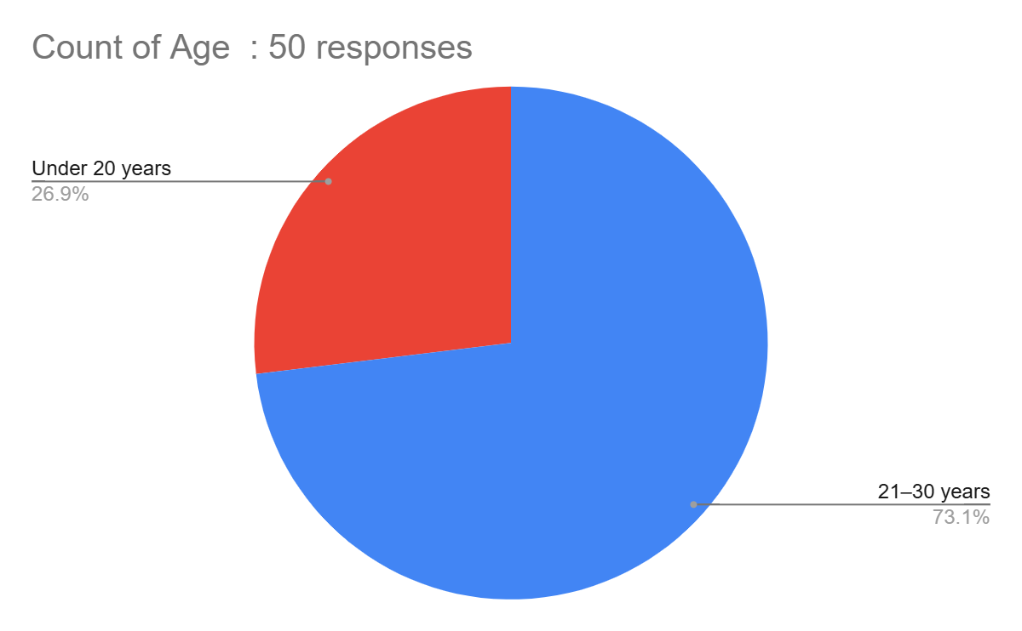
Interpretation: The vast majority of respondents (73.1%) are young professionals aged 21–30 years.

Fig 5.2 Gender of the respondents
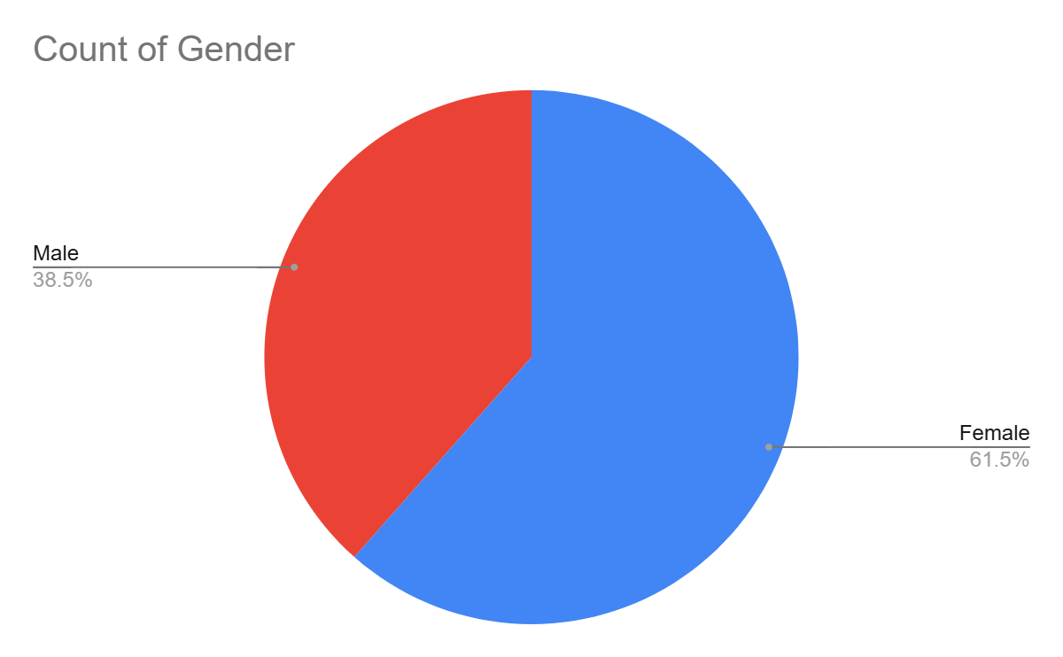
Interpretation:The survey received more responses from female participants (61.5%) than male participants (38.5%).
Fig 5.3 Education of the respondent
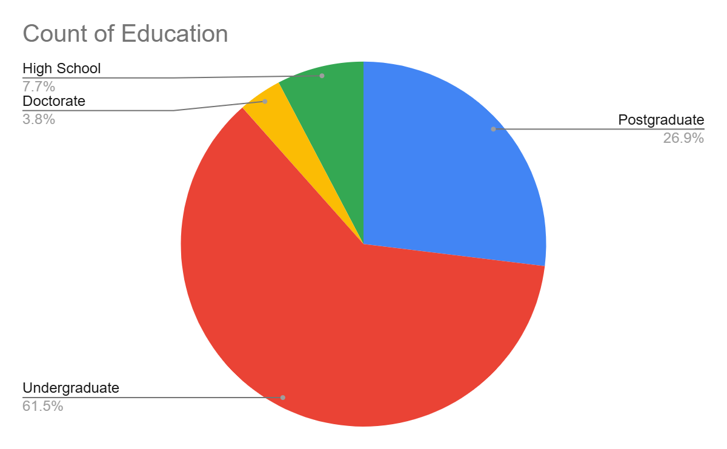
Interpretation:The majority of respondents hold either an Undergraduate (61.5%) or a Postgraduate (26.9%) degree and high school (7.7%)

Fig 5.4 Economic intelligence of the respondents
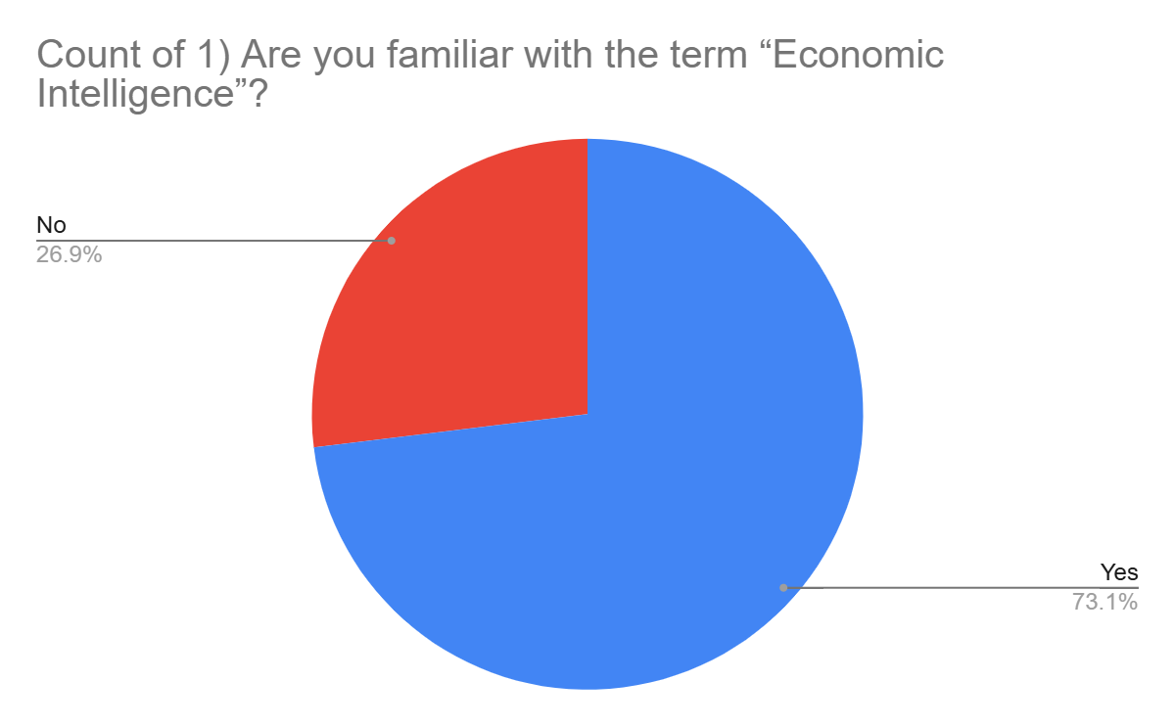
Interpretation: A large majority of respondents (73.1%) are familiar with the term “Economic Intelligence.”

Fig 5.5 Economic intelligence in organisational decision making
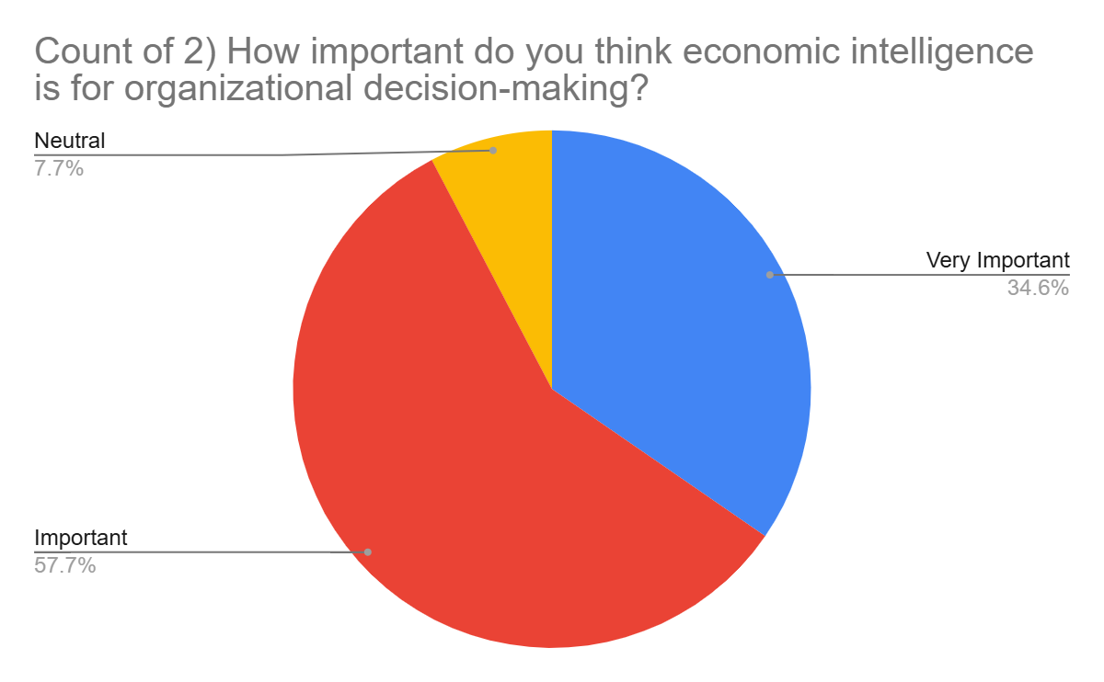
Interpretation: Almost all respondents view economic intelligence as either important (57.7%) or very important (34.6%) and neutral (7.7% )for organisational decision-making.

Fig 5.6 Economic intelligence in strategy formulation
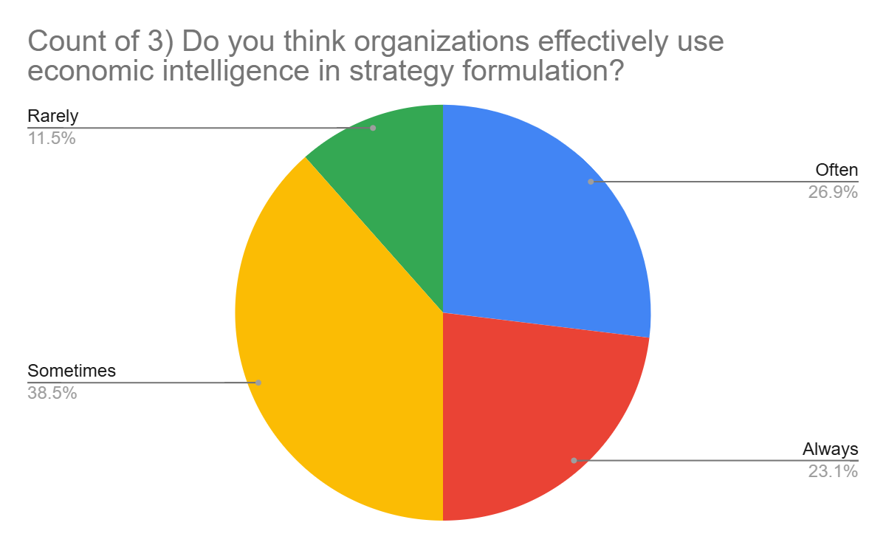
Interpretation:Opinion is split,with organisations using economic intelligence in strategy formulation sometimes (38.5%) ,Often (26.9%)or always (23.1) or rarely(11.5%)

Fig 5.7 Data analytics in decision making
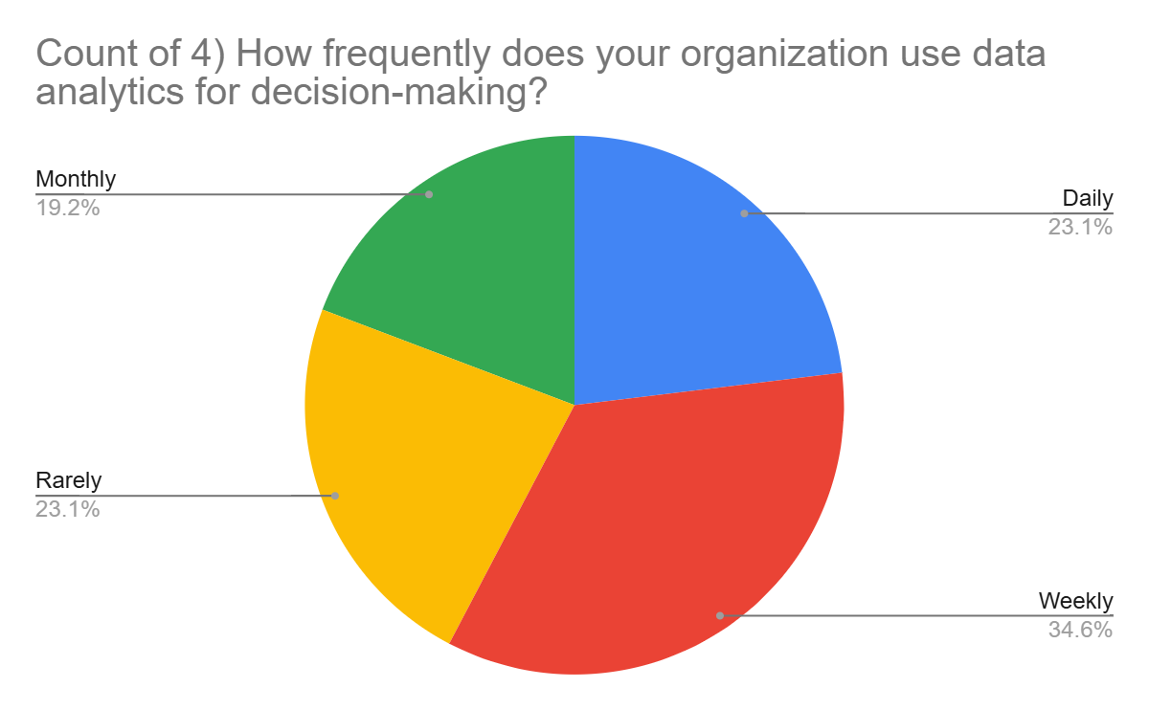
Interpretation:Opinion is split,with organisations using economic intelligence in strategy formulation monthly(19.2%) , rarely and daily (23.1%) and weekly (34.6%)

Fig 5.8 Organisation strategy in data analytics
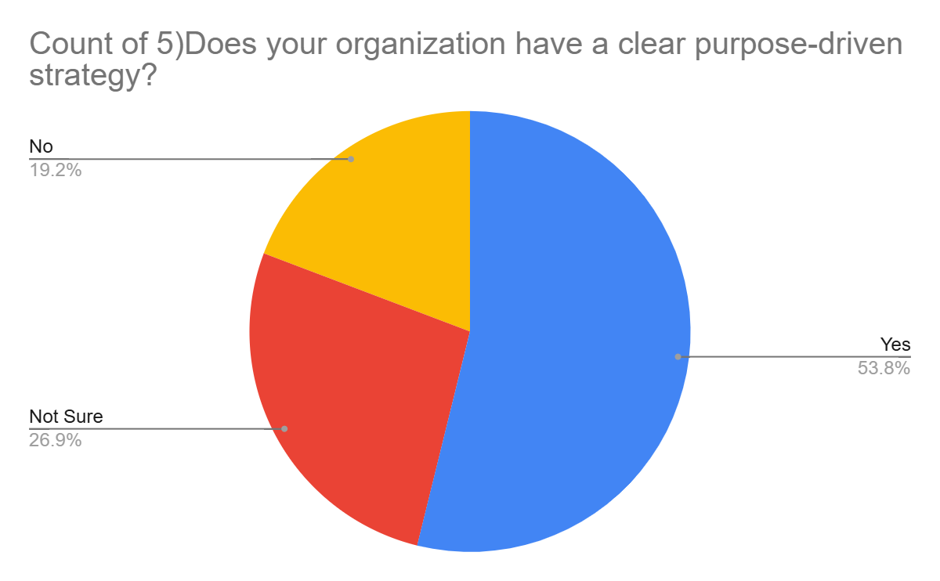
Interpretation: organization purpose strategy, yes (53.8%) or No( 19.2%) or not sure (26.9%) in terms of data analytics

Fig 5.9 long term competitive advantage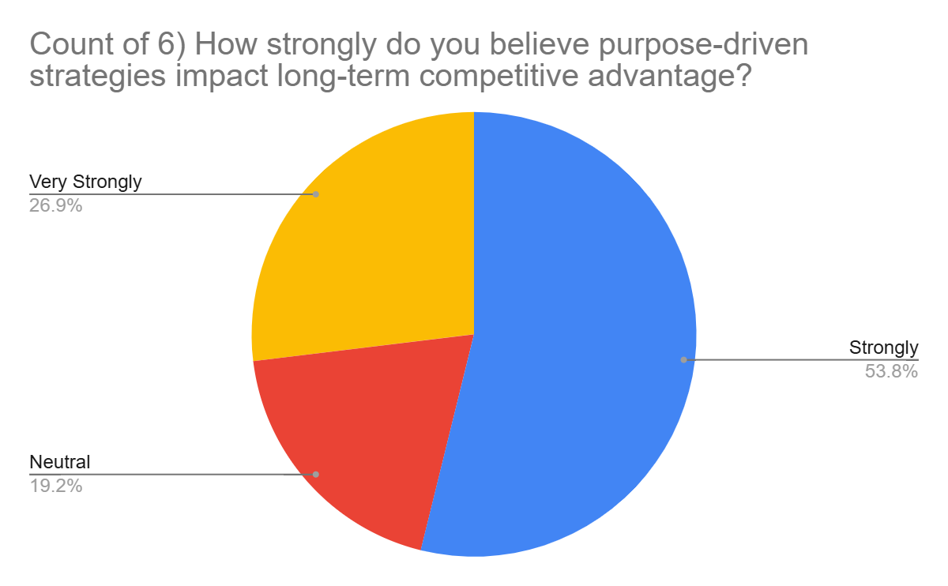Interpretation:Most respondents strongly believe that purpose-driven strategies impact long-term competitive advantage, with Strongly (51.9%) and Very Strongly (26.9%) being the top answer

Fig 5.10 long term competitive advantage
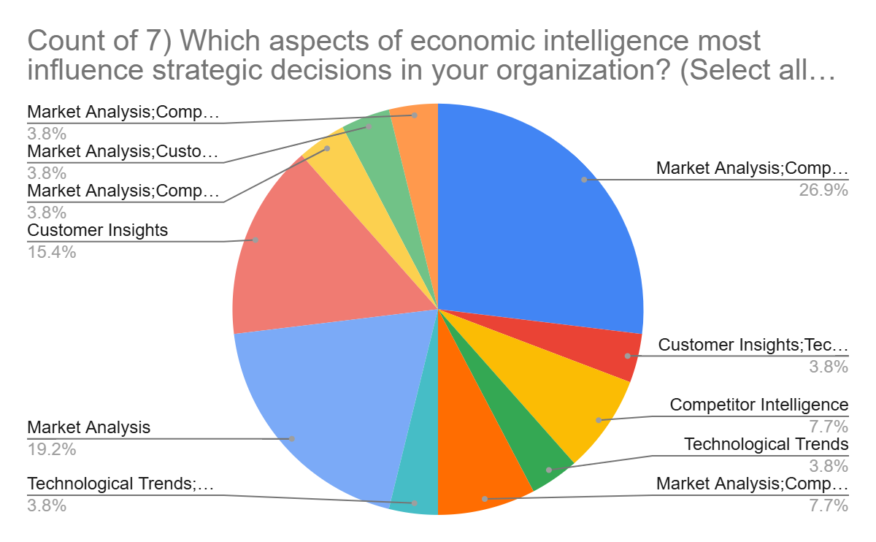
Interpretation:Most of the respondent choose( market structure 3.8% ) and technological trends ( 3.8%)

Fig 5.11 Economic intelligence improves accuracy
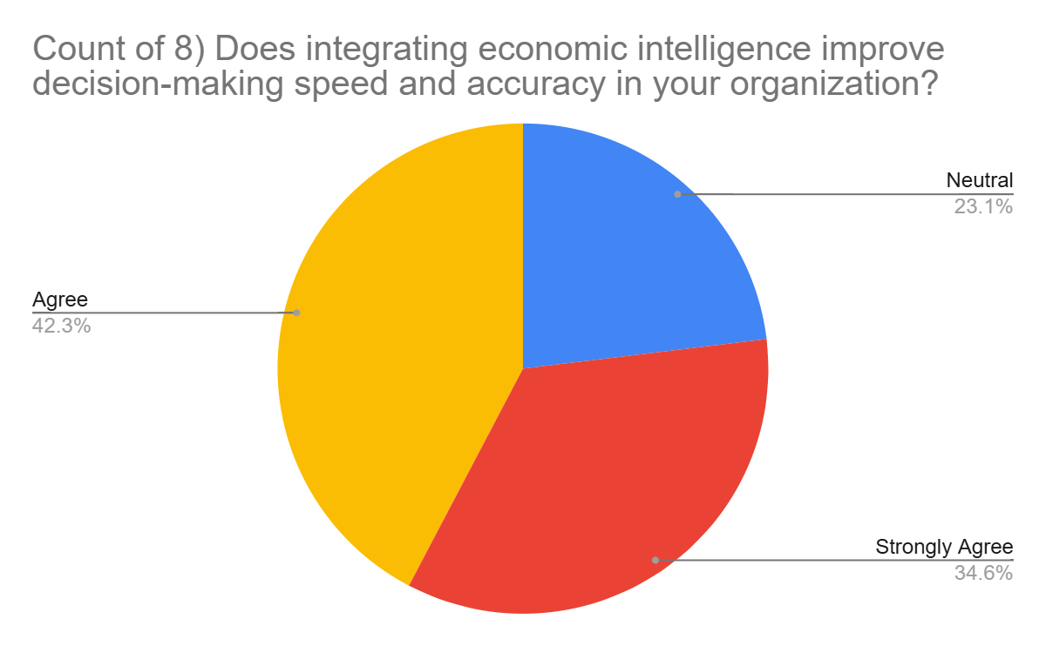
Interpretation: Economic intelligence improve decision making speed and accuracy Agree(42.3%) neutral(23.1%) and strongly Agree(34.6%)

Fig 5.12 Predictive analysis tools used in organisation
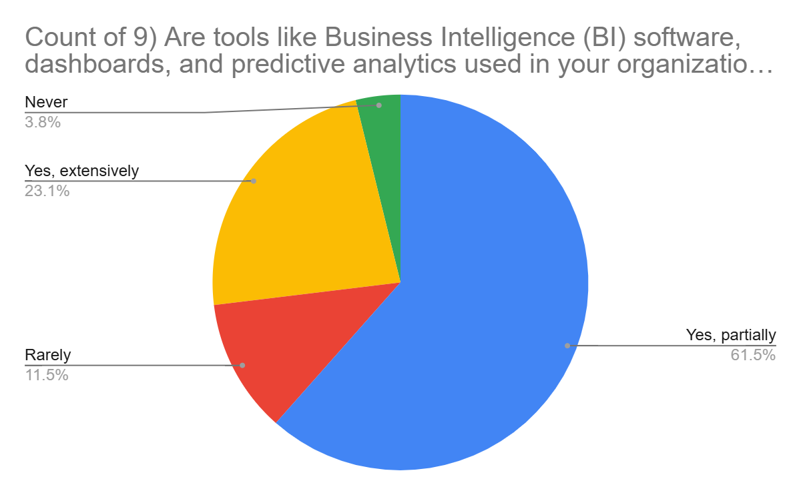
Interpretation :A strongly majority of respondents agree (42.3%) or strongly agree(34.6) that integrating economic intelligence improves decision-making speed and accuracy.

Fig 5.13 Predictive analysis tools efficiency
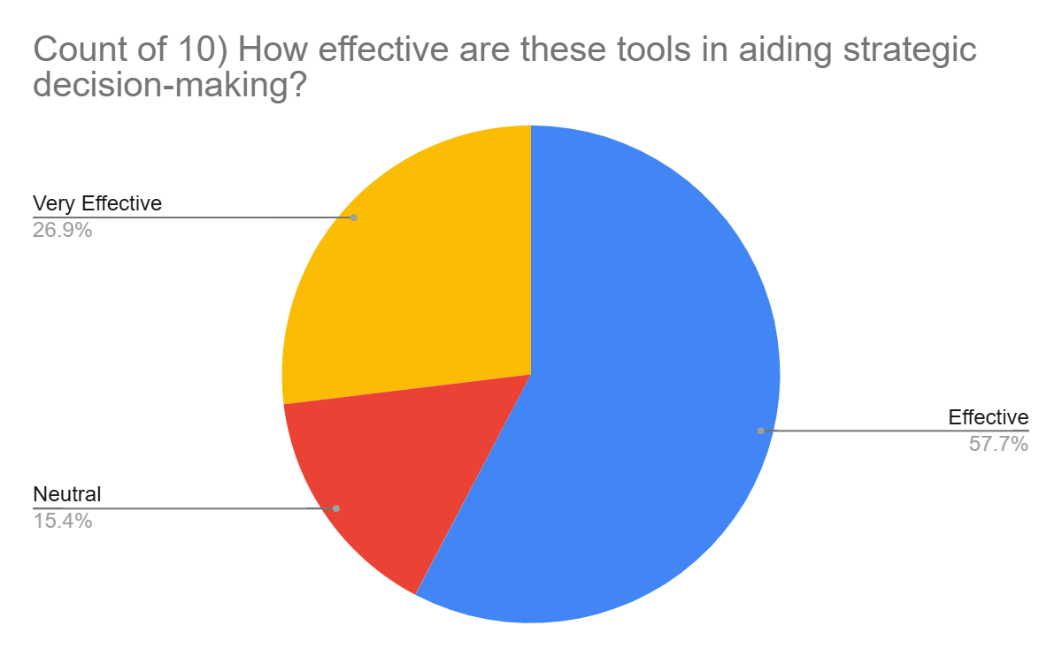
Interpretation: Such tools are widely used, with most organizations effective (57.7%) neutral(15.4%) and very effective( 26.9%).

Fig 5.14 Training on intelligence tools in organization
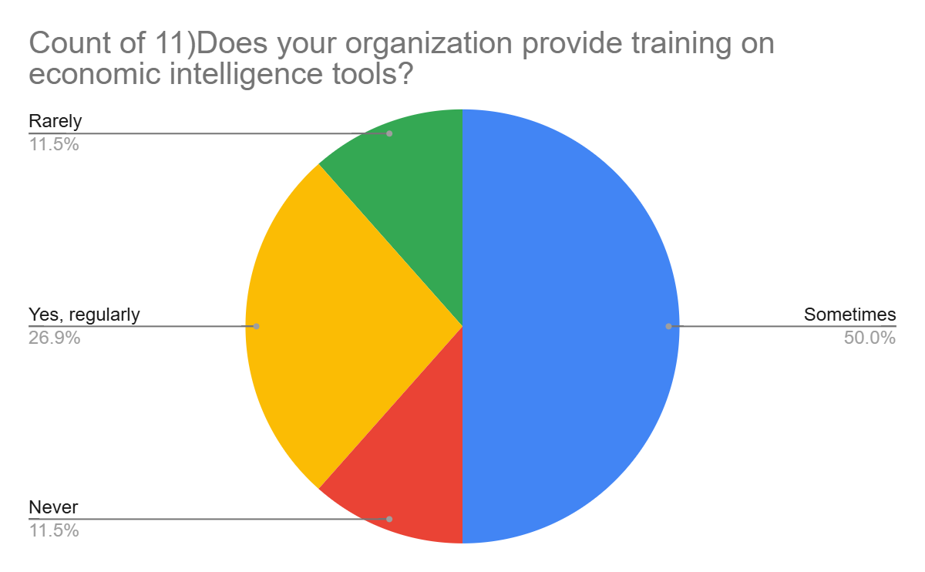
Interpretation: The majority of respondents Training on intelligence tools in organization are sometimes (50%) , yes regularly(26.9%), Never(11.5%)

Fig 5.15 Integrating economic intelligence
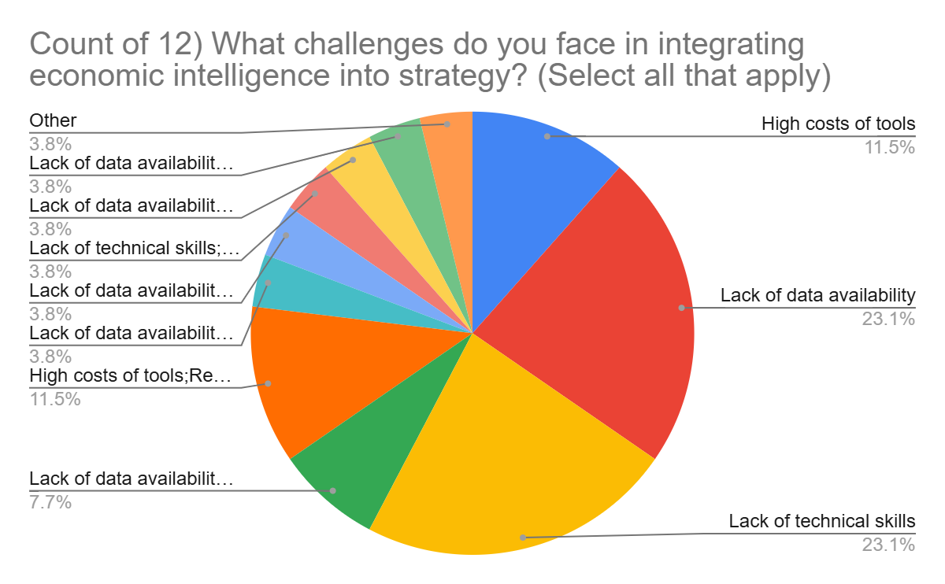
Interpretation: The primary challenges are the lack of data availability(23.1%) and high cost of tools(11.5%).

Fig 5.16 Business competitiveness in economic intelligence
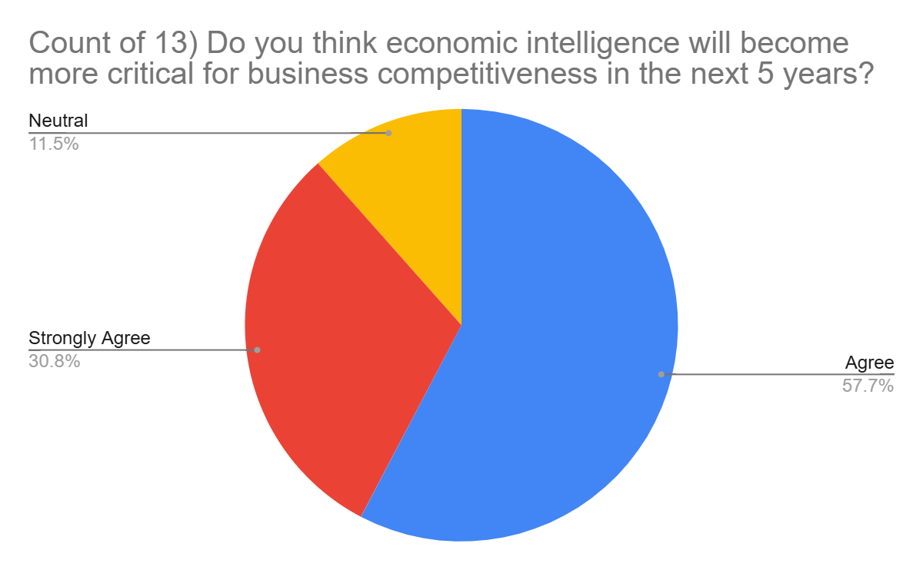Interpretation: An overwhelming majority agree(57.7%) or strongly (30.8%) or neutral
(11.5%) that economic intelligence will become more critical in the next 5 years.

Fig 5.17 AI- driven economic intelligence solution
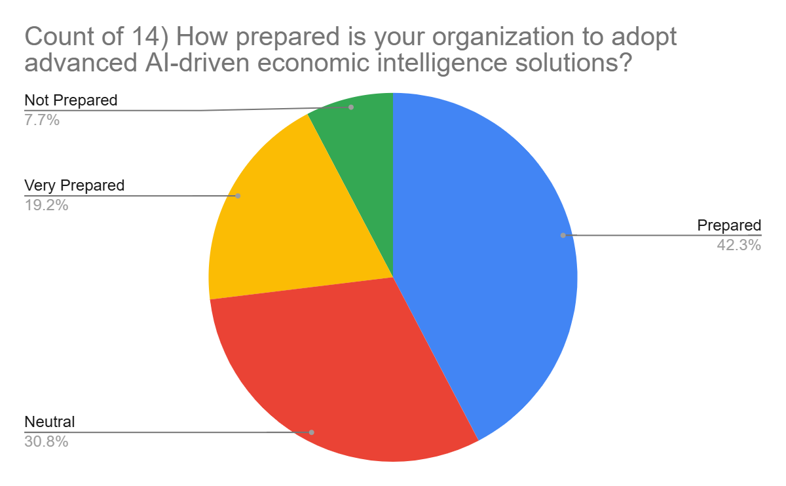
Interpretation: Organisations are generally prepared with most rating themselves as prepared (42.3%) or very prepared (19.2%)

Fig 5.18 Economic intelligence for strategic advantage

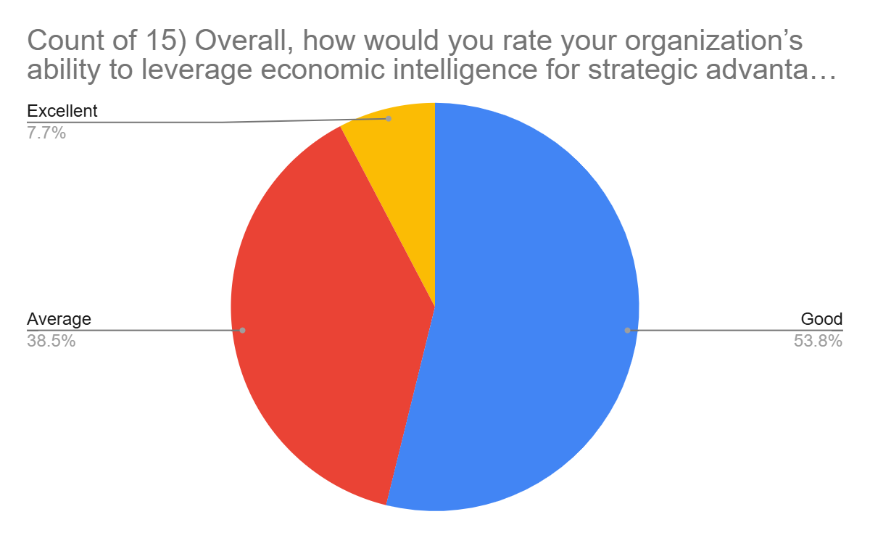
Interpretation: Most respondents rate their organizations ability to leverage EI as good (53.8%) or average (38.5%).

VI. FINDINGS AND DISCUSSIONS
Findings​‍​‌‍​‍‌​‍​‌‍​‍‌
The study findings reveal that Artificial Intelligence (AI) has become a major factor in the modern decision-making process, especially in the areas of business and economics. First of all, the data gathered from the respondents show that people are quite aware of the AI applications and they understand them well as most of them have already used AI tools like ChatGPT, Google Bard, and data analytics software. Hence, AI technologies are becoming more and more deeply intertwined in academic and professional spheres.
The participants in the survey mostly thought that AI helps a lot in making decisions more efficiently, accurately, and on time as the system can process huge volumes of data and at the same time come up with predictive insights. But still, the respondents to the survey emphasized the retention of the human intuition side by pointing out that even though using AI is advantageous, human intuition should not be discarded. According to them, ethical judgment, creativity, empathy, and even understanding the context are some of the decision-making aspects in which AI systems cannot be involved as these are human characteristics.
The research also indicates that while people trust AI to be their helper in the interpretation and analysis of data, they are not comfortable with the idea of letting AI-generated results be used without human intervention. Such a slight trust level indicates that people view AI as a tool to facilitate decision-making rather than a decision-maker that can act independently. The ethical and emotional aspects of the argument were also the focus of people who replied to the survey stating that the main risks include biased algorithms, misuse of data, and lack of transparency in AI operations. A large number of people who took part in this survey think that moral standards and human control are indispensable in ensuring that AI technologies behave fairly and are accountable to users.
To sum up, the results of the study point to the conclusion that the best decision-making is the one that results from the conjunction of human intuition and artificial intelligence functioning in a complementary way. This synergy combines the analytical rigor of AI with the hands-on wisdom and moral judgment of humans and, as a result, the strategic outcomes become more balanced and better informed. The findings here align with the main proposition of the paper that the future of economic strategies is not by the doing away of human intelligence with machines but by the creation of a partnership between the two which is mutually ​‍​‌‍​‍‌​‍​‌‍​‍‌beneficial.
Discussion
The​‍​‌‍​‍‌​‍​‌‍​‍‌ study results illustrate a shift of the relationship between human intuition and artificial intelligence (AI) in economic and strategic decision-making to a new level. The respondents' increased knowledge and use of AI show that the technology is not seen anymore as a remote or purely technical tool but as an indispensable element of everyday professional reasoning. The discussion conveys that, although AI is very effective in data processing, pattern recognition, and predictive analytics, it is still the human intuition and contextual understanding that should direct it. Respondents' comments to the effect that human judgment furnishes the moral, imaginative, and emotional aspects that the machine cannot have naturally is a crucial point. The emphasis is placed on the fact that decision-making in complicated economic contexts should not be done solely on the basis of algorithmic correctness but should involve human awareness of social, ethical, and cultural factors.
The results correspond to the current studies that propose a 'hybrid intelligence' model where humans and machines are on the same team, helping each other, not competing. The trust level in AI, as per participants, is not very high and so it reflects a hopeful yet careful attitude towards AI. People value AI's capabilities but they are not oblivious of its limitations, e.g. risk of bias, issues with data privacy, and lack of transparency. This opinion commitment to the necessity of having humans still in control of the decisive steps so as to guarantee accountability and the ethical equilibrium is strengthened by the same perspective. Besides, it points to the momentum for companies and the education sector to prepare people not only with the technical skills but also with the ethical ones to be able to navigate the AI-integrated environment responsibly.
The discussion, which is less technical and more philosophical, points out that the mutual support between human intuition and AI can fundamentally change the way strategic decisions are made in business and economics. The fusion of AI's computing power with human interpretive and empathetic skills can lead to more holistic and sustainable results for the organizations. So, it's not a matter of selecting either human or artificial intelligence, but rather a question of developing a fruitful collaboration between the two that is the way ahead—technological progress should be consistent with human values, creativity, and ethical ​‍​‌‍​‍‌​‍​‌‍​‍‌advancement.

VII. CONCLUSION
The research "Bridging Human Intuition and Machine Intelligence in Economic Strategy" concludes that the economic decision-making future is in a harmonious blending of human intuition and artificial intelligence. The research confirms that although AI greatly increases analytical accuracy, data analysis, and predictive capability, it cannot replace human intuition depth, ethics, and creativity. Human intelligence brings the context, emotional intelligence, and moral discernment that keep economic choices ethical, fair, and socially just.
Respondents were highly aware of AI tools and recognized the central role they have to play in enhancing effectiveness and strategic vision. But they underscored that human intervention is still critical in bringing contextual sense to AI-driven insights and holding people accountable. This means that AI is not viewed as a human intelligence substitute but rather as a partner that enhances human ability. The research also points to ongoing challenges—data transparency, algorithmic bias, and ethical governance on which attention needs to be directed in order to foster trust and enduring AI adoption.
Essentially, the study determines that hybrid intelligence, the alignment of human gut instincts and machine accuracy, is best suited for contemporary economic planning. This collaboration generates wiser, quicker, and more accountable decision making fueling long-term competitive edge, creativity, and enduring economic growth. The economic intelligence's ultimate success lies not in deciding whether humans or machines are best but in developing cooperation between them to produce an equal, moral, and visionary strategic future.

VIII. REFERENCES

1. https://doi.org/10.4468/2022.2.12delbufalo.dibernardo.risso
2 https://doi.org/10.1007/s40685-020-00133-x
3 https://doi.org/10.60087/jaigs.v7i01.361
4 https://doi.org/10.1109/access.2022.3177657
5 https://doi.org/10.55041/ijsrem52320
6 https://doi.org/10.23919/picmet.2019.8893938
7 . https://doi.org/10.3233/hsm-2004-23208
8 . https://doi.org/10.56811/pfi-24-0015
9 . https://doi.org/10.4324/9780429486982-3
10. https://doi.org/10.1016/j.cirpj.2019.11.005
11.https://doi.org/10.36948/ijfmr.2025.v07i05.55481
12. Ghadage, N. S. S. (2025). Revolutionizing Intelligence: Synergizing human and artificial intelligence. Journal of Information Systems Engineering & Management, 10(37s), 1108–1117. https://doi.org/10.52783/jisem.v10i37s.6762
13.Harré, M. S. (2021). Information theory for agents in artificial intelligence, psychology, and economics. Entropy, 23(3), 310. https://doi.org/10.3390/e23030310
14. Pescetelli, N. (2021). A brief taxonomy of hybrid intelligence. Forecasting, 3(3), 633–643. https://doi.org/10.3390/forecast3030039
15.Kitsios, F., & Kamariotou, M. (2021). Artificial Intelligence and Business Strategy towards Digital Transformation: A Research Agenda. Sustainability, 13(4), 2025. https://doi.org/10.3390/su13042025
16.Shrestha, Y. R., Ben-Menahem, S. M., & Von Krogh, G. (2019). Organizational Decision-Making structures in the age of artificial Intelligence. California Management Review, 61(4), 66–83. https://doi.org/10.1177/0008125619862257
17.https://www.scribbr.com/citation/generator/folders/y5vgBuokEQBUUYBEizbw5/lists/6PPJ00TdEI2xUib3L3gXr/sources/7ckXbHXJ3LI4Vcsagaphx4/
18.https://www.scribbr.com/citation/generator/folders/y5vgBuokEQBUUYBEizbw5/lists/6PPJ00TdEI2xUib3L3gXr/sources/7ckXbHXJ3LI4Vcsagaphx4/
19. https://doi.org/10.1126/science.aaa8403
20.https://doi.org/10.1007/s13132-023-01183-2
21. https://doi.org/10.1016/j.bushor.2018.03.007
22. https://doi.org/10.1177/1094670517752459
23.. https://doi.org/10.1016/j.ijinfomgt.2019.08.002
24.https://doi.org/10.1080/08874417.2023.2165197
25.https://doi.org/10.1016/j.inffus.2019.12.012
26.https://doi.org/10.1109/dese.2015.22
27.https://doi.org/10.32996/jefas.2024.6.6.8
28. https://doi.org/10.1007/s12599-019-00595-2
29.https://doi.org/10.48550/arxiv.2301.08144
30.https://doi.org/10.26480/csmj.01.2024.49.59

